**Automated Network Management Using Servicenow**

**Introduction**

In modern enterprise environments, managing network infrastructure manually is inefficient, error-prone, and unable to scale with increasing demand. Automated Network Management (ANM) integrated with ServiceNow provides a streamlined, proactive, and data-driven approach to network operations. This solution leverages ServiceNow’s IT Service Management (ITSM) and orchestration capabilities to automate common network tasks, improve incident resolution times, and enhance overall network reliability.

**Background & Problem Statement**

In many organizations, network requests are handled through emails, spreadsheets, or ad-hoc ticket systems, leading to:

* Delayed responses due to manual approvals.
* Inconsistent request formats.
* Lack of visibility into request status.
* Errors in configuration changes.

**Solution:**  
Implement a ServiceNow-based automated workflow for network requests that routes, approves, and fulfills tasks seamlessly, reducing human intervention and ensuring compliance.

**Objectives**

The primary objectives of implementing Automated Network Management with ServiceNow are:

Reduce Mean Time to Resolution (MTTR) for network incidents.

Automate repetitive tasks such as device configuration backups, port resets, and monitoring alerts.

Provide real-time visibility into network health and performance.

Enhance compliance with configuration and security policies.

Improve collaboration between Network Operations Center (NOC) teams and IT support.

**Scope**

**This project covers: Automated Incident Detection** – Integrating network monitoring tools (e.g., SolarWinds, Nagios, Cisco DNA Center) with ServiceNow for real-time incident creation.

**Automated Remediation** – Using ServiceNow workflows and orchestration to trigger scripts or API calls for common fixes.

**Change Management Automation** – Auto-generating change requests for network upgrades or configuration changes.

**Reporting and Analytics** – Dashboards for network KPIs such as uptime, incident trends, and SLA compliance.

**Self-Service Portal** – End-users can request network services (e.g., VLAN changes, access point resets) via ServiceNow.

**System Architecture**

**Technical Design**

**Architecture Diagram:**

User → ServiceNow Service Catalog → Approval Workflow → Network Tool Integration → CMDB Update → Completion Notification

**Key Components:**

**Network Monitoring Tools** – Detect and alert network events.

**ServiceNow ITSM** – Centralized ticketing, workflow automation, and reporting.

**Orchestration Engine** – Executes automated remediation scripts via ServiceNow Orchestration or IntegrationHub.

**Configuration Management Database (CMDB)** – Stores network device inventory and relationships.

**APIs and Webhooks** – Enable real-time data exchange between monitoring tools and ServiceNow.

**Workflow Example:**

Network monitoring tool detects high CPU usage on a core switch.

Alert is sent via webhook/API to ServiceNow.

ServiceNow creates an incident ticket with device details from CMDB.

Automated workflow checks for known issues and runs a remediation script.

If resolved, ticket is automatically closed and a summary is sent to NOC.

If unresolved, ticket is escalated to a network engineer.

**Benefits**

**Proactive Issue Resolution** – Problems can be fixed before users notice them.

**Reduced Downtime** – Faster remediation of network faults.

**Operational Efficiency** – NOC staff focus on complex tasks instead of repetitive work.

**Improved SLA Compliance** – Automated escalation ensures timely responses.

**Better Data Accuracy** – CMDB remains up-to-date with automated discovery.

**Security and Compliance**

**Access Controls** – Only authorized personnel can trigger automation workflows.

**Audit Trails** – All automated changes are logged in ServiceNow.

**Policy Enforcement** – Automated scripts ensure network configurations comply with security policies.

**Functional Requirements**

1. **Service Catalog Forms**
   * Custom forms for each network request type.
   * Mandatory fields for request details (e.g., IP range, VLAN ID, rule justification).
2. **Workflow Automation**
   * Automatic assignment to appropriate network team.
   * Conditional approvals based on request type.
3. **Integration**
   * API calls to network tools (e.g., Cisco DNA Center, Infoblox) for automated execution.
   * Auto-update CMDB entries post-implementation.
4. **Notifications & SLAs**
   * Email/SMS notifications at each stage.
   * SLA timers for request handling.

**Key Features**

1. **Service Catalog Item** – Custom catalog item for “Network Request” with dynamic fields.
2. **Workflow Automation** – End-to-end automated workflow in ServiceNow Flow Designer.
3. **Approval Chains** – Conditional approvals based on request type, department, or cost.
4. **Integration** – API integration with network automation tools for configuration execution.
5. **Notifications** – Automated email/SMS updates for every stage.
6. **Reporting & Analytics** – SLA performance, request trends, and backlog insights.

**Results**

**Output Screenshots**

* ServiceNow Catalogue
* Creation of Table
* Request Approvals Creation(Related List)
* Overview of flows,Actions in Flow Designer
* Creation & Implementation of flows, Actions in Flow Designer
* Final Testing in End User portal & Instance

**ServiceNow Catalogue**

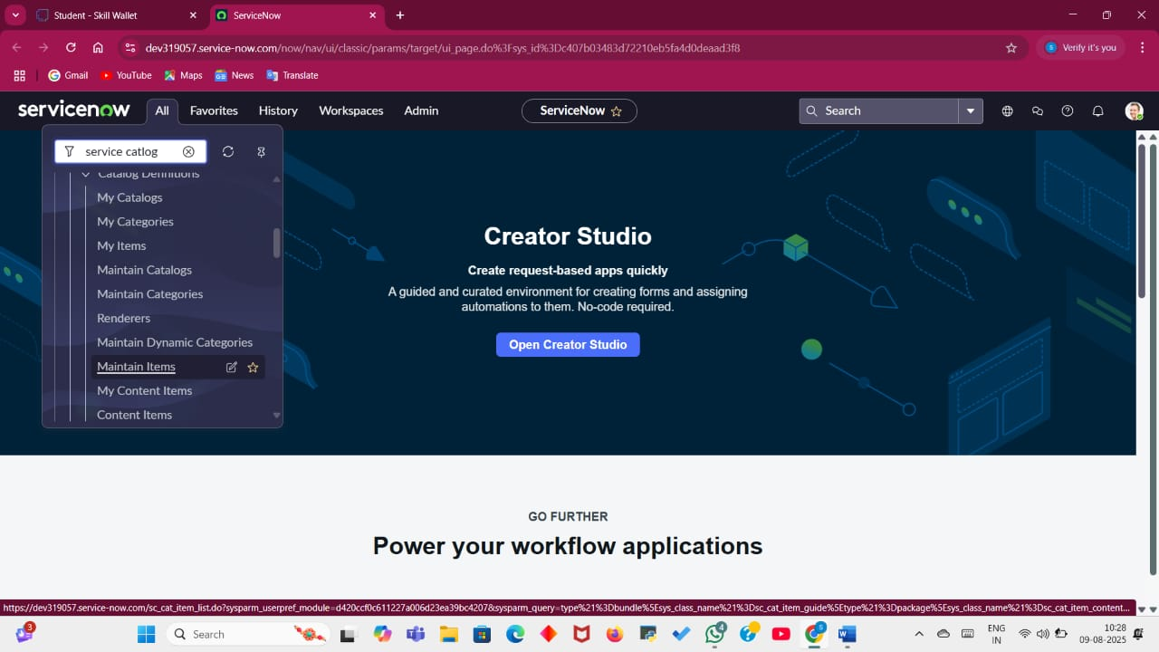

**Creation of Table**

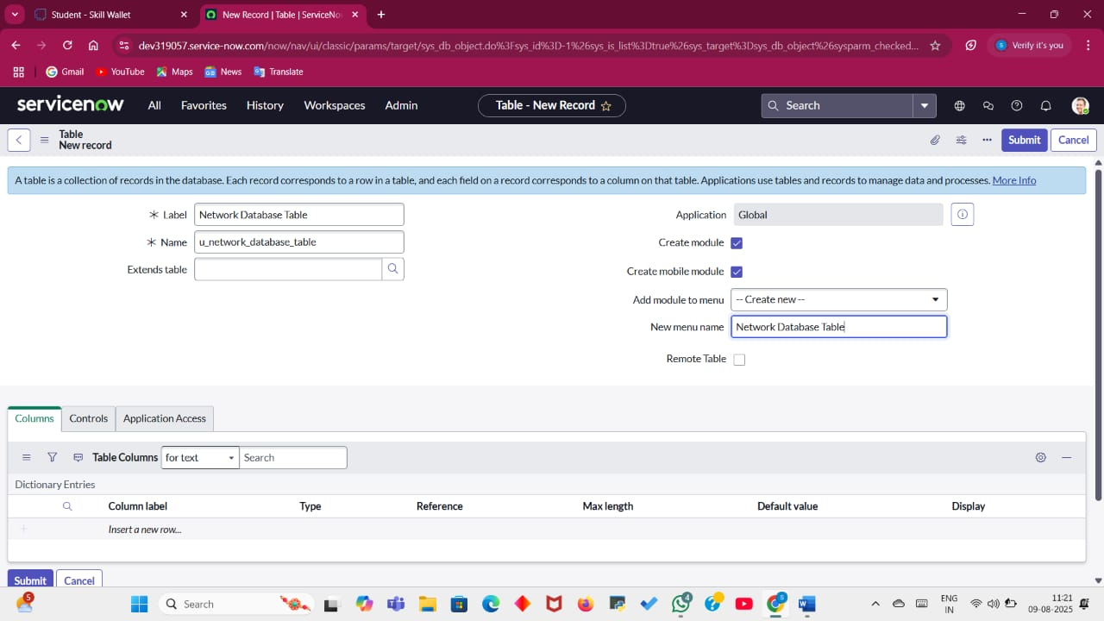

**Creation of fields**

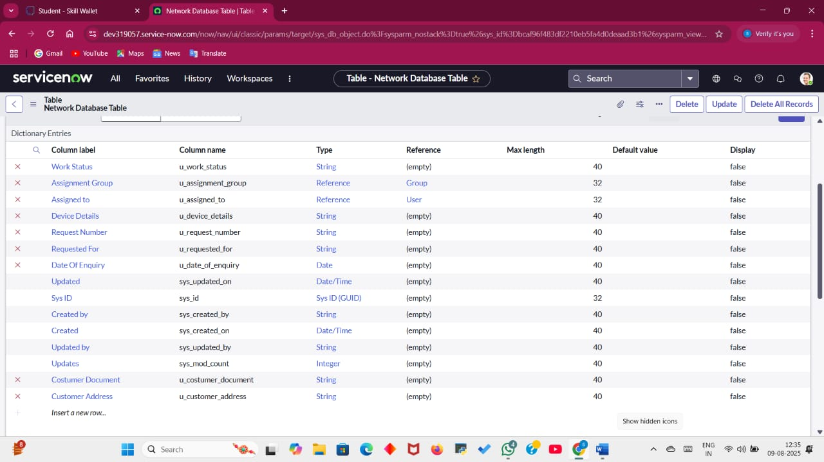

**Request Approvals Creation(Related List)**

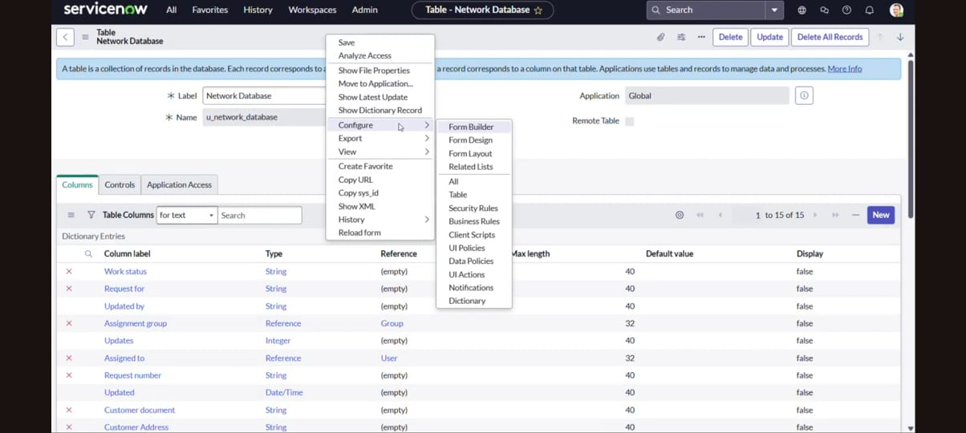

**Overview of flows , Actions in Flow Designer**

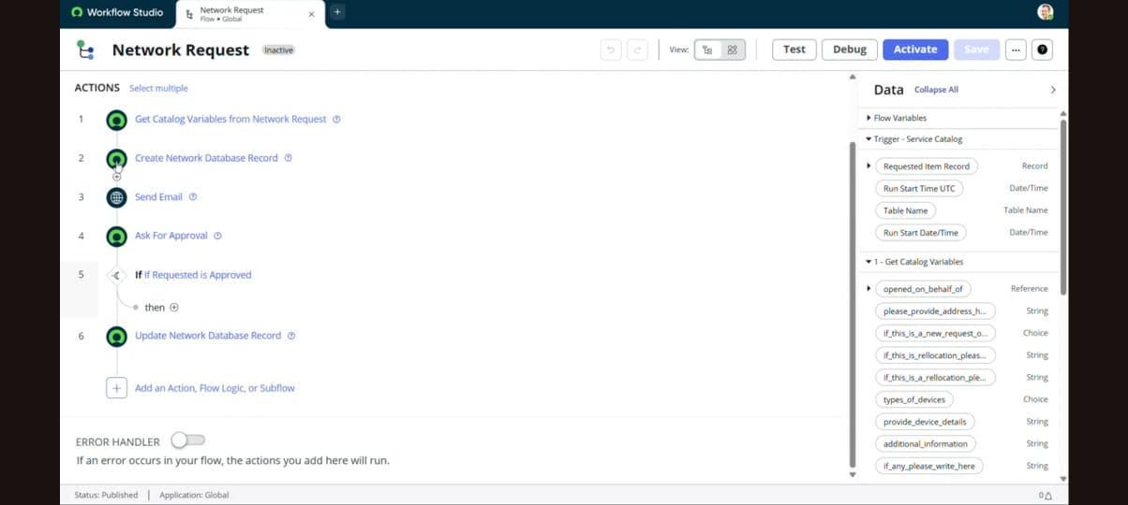

**Testing in Service Portal(End User)**

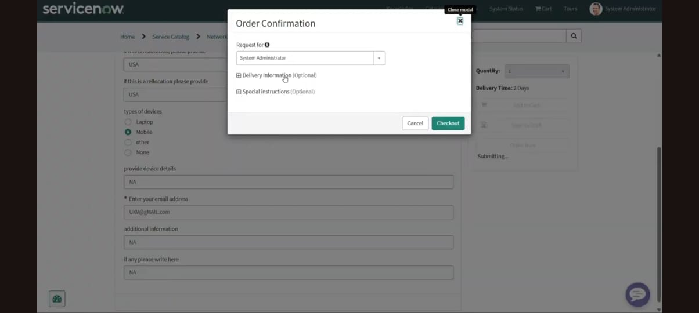

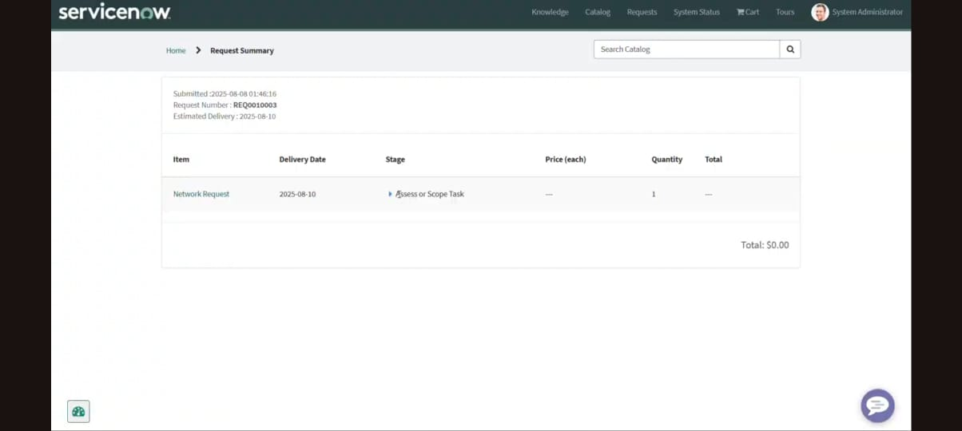

**Implementation Plan**

Phase Activities Duration

**Phase 1:** Assessment Requirements gathering, tool inventory, CMDB audit 2 weeks

**Phase 2:** Integration Setup API/webhook integration between monitoring tools and ServiceNow 3 weeks

**Phase 3:** Workflow Development Build and test automated remediation workflows 4 weeks

**Phase 4:** Pilot Run Deploy automation for selected network segments 2 weeks

**Phase 5:** Full Deployment Expand automation across all network devices 3 weeks

**Phase 6:** Optimization Refine workflows, add new automation use cases Ongoing

| **Phase** | **Activities** | **Deliverables** |
| --- | --- | --- |
| **1. Requirement Gathering** | Meet stakeholders, identify request types, approval chains. | Requirement Document |
| **2. Design** | Create catalog forms, workflows, integration plans. | Design Document |
| **3. Development** | Configure ServiceNow catalog items, workflows, APIs. | Configured Instance |
| **4. Testing** | Unit testing, UAT with network team. | Test Report |
| **5. Deployment** | Move configuration to production. | Go-Live Checklist |
| **6. Training & Handover** | Train network team and helpdesk. | Training Materials |
|  |  |  |

**Risk Management**

| **Risk** | **Impact** | **Mitigation** |
| --- | --- | --- |
| API failure with network tools | Medium | Retry mechanism, fallback to manual |
| Incorrect request data | High | Mandatory field validation |
| Approval delays | Medium | Auto-reminders, escalation rules |

**Project Scope**

**In Scope:**

* Network service request types:
  + IP address allocation/release
  + VLAN creation/modification
  + Firewall rule creation/removal
  + Network port activation/deactivation
* Service Catalog integration.
* Automated approval workflows.
* CMDB updates for network assets.
* Integration with network management tools via API.

**Out of Scope:**

* Physical network hardware procurement.
* End-user device configuration.

**Functional Requirements**

1. **Service Catalog Forms**
   * Custom forms for each network request type.
   * Mandatory fields for request details (e.g., IP range, VLAN ID, rule justification).
2. **Workflow Automation**
   * Automatic assignment to appropriate network team.
   * Conditional approvals based on request type.
3. **Integration**
   * API calls to network tools (e.g., Cisco DNA Center, Infoblox) for automated execution.
   * Auto-update CMDB entries post-implementation.
4. **Notifications & SLAs**
   * Email/SMS notifications at each stage.
   * SLA timers for request handling.

**Example Use Cases**

Automated switch port reset when a port is down.

Automatic configuration backup after a change is made.

Dynamic VLAN assignment based on ServiceNow request approvals.

Incident auto-resolution when a link recovers.

Firewall Rule Automation

Bandwidth Optimization

IP Address Management (IPAM

Automated Device Onboarding

Proactive Hardware Replacement Alerts

Change Management for Firmware Upgrades

**Monitoring & Maintenance**

* Regular workflow audit.
* SLA performance reporting.
* Integration health checks.
* Periodic updates for catalog items.

**Conclusion**

The implementation of Automated Network Management using ServiceNow represents a significant leap from traditional, reactive IT operations to a proactive, intelligence-driven approach. By integrating network monitoring tools, orchestration workflows, and the CMDB into a unified ServiceNow ecosystem, the project not only accelerates incident resolution but also ensures higher accuracy, compliance, and visibility across the network infrastructure.

Through automated remediation, repetitive and error-prone manual tasks are eliminated, allowing Network Operations Center (NOC) teams to focus on complex, value-driven initiatives. The solution’s real-time dashboards and SLA tracking mechanisms empower management with actionable insights, ensuring that performance standards are consistently met or exceeded.

From a business perspective, this approach reduces downtime, lowers operational costs, and enhances end-user satisfaction by delivering faster, more reliable network services. Furthermore, the integration of security policies and audit trails ensures that every network change aligns with organizational compliance requirements, minimizing risks.

With its modular design, the system is built to adapt and scale — future enhancements could include AI-driven predictive maintenance, advanced analytics for capacity planning, and mobile-friendly self-service options for greater accessibility. Ultimately, this project lays the groundwork for a more agile, resilient, and intelligent IT infrastructure, aligning with modern digital transformation goals and positioning the organization for long-term operational excellence.

**Future Scope**

**• AI-Powered Predictive Maintenance –** Integrate AI/ML algorithms with ServiceNow’s data feeds to predict potential network failures before they occur, enabling preemptive actions and further reducing downtime.

**• Advanced Analytics Dashboards –** Expand existing dashboards to include trend analysis, capacity planning, and anomaly detection, giving IT leaders deeper insights into performance patterns and resource utilization.

• **Mobile-First Access & Control** – Develop a mobile-optimized self-service portal and admin interface, allowing end-users and NOC staff to request, approve, and monitor network services from any device.

• **Role-Based and Context-Aware Access** – Enhance security by implementing granular, context-based access controls where permissions adapt based on location, device, and time.

**• Integration with Cloud Networking Platforms –** Extend automation capabilities to hybrid and multi-cloud environments (e.g., AWS, Azure, Google Cloud) for unified network management.

**• Chatbot-Driven Self-Service** – Deploy AI chatbots integrated with ServiceNow Virtual Agent to guide users through network requests, troubleshooting steps, and status checks without human intervention.

• **Automated Compliance Audits** – Schedule and execute regular compliance scans for network configurations, with automated reporting to satisfy internal audits and regulatory requirements.

• **Zero-Touch Provisioning** – Enable fully automated provisioning of new network devices via API integration, ensuring instant setup and configuration without manual input.

• **Disaster Recovery Automation** – Incorporate automated failover and recovery workflows to minimize impact during critical outages or disasters.

**Appendix**

* Source Code: No external code; used ServiceNow platform
* Dataset Link: Not applicable
* GitHub Link: https://github.com/Pavithra281004